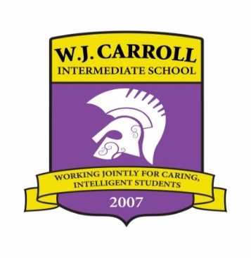

**W. J. Carroll Intermediate**

**6TH GRADE SUPPLY LIST**

**2023-2024**

* 4 – Dozen #2 Ticonderoga pencils
* 2 – Packages Crayola crayons, 24 count
* 2 – Packages full length colored pencils, 12 count
* 2 – Packages Expo dry erase markers (4-PACK )
* 6 – Composition notebooks
* 6 – Boxes facial tissue
* 3 – Containers disinfecting wipes